Chesterton Festival 24th – 26th June

Photography Competition 2011

The subject for this year’s photography is

‘Recreation & Leisure’

If you start now, you will have winter, spring and the summer months to take lots of action shots, or not as the case may be, to get that one ‘special moment’ which will capture the judges’ eye.

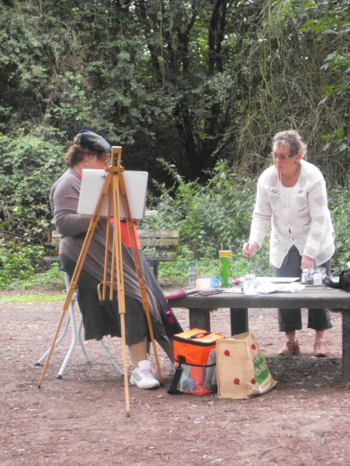 

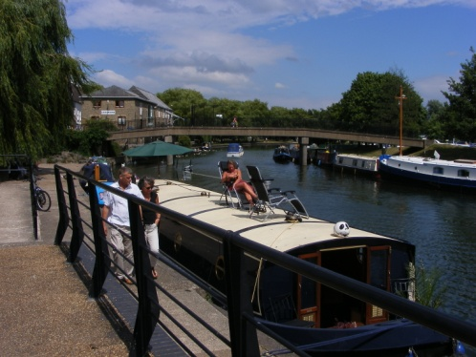 

Just a few ideas! The world is your oyster, as they say. So get out there and start snaping and

clicking away.

For your entry form , please contact ………………………………………………………………………………………….

If you do not have a camera, we have a number of free disposable cameras you could use for the competition. Please ask for more details where you see this poster or email [tenansnews@btinternet.com](mailto:tenansnews@btinternet.com)

November 2010